**INDEPENDENT COMPONENT ANALYSIS**

ICA, unlike PCA that focuses on maximizing the data points, is another feature extraction technique that concentrates more on independent components. The main aim is to find linear representation of non-gaussian data in order for the components to be either statistically independent or as independent as possible. It can be said that ICA is somewhere related on Principal Component Analysis, but it is more powerful as it is used as a signal separation and dimensionality reduction method to identify hidden underlying independent features from the mixed signals.

ICA can be explained better with an example such as, a person in a party is talking to two of his friends who are standing at different distances from him. Although one of them is closer to him, he can still hear both but the sound signal of both of his friends’ voices reaches him as a mixed signal. His brain further un-mixes these signals and perceive their voices in a way such that the closer one’s voice signal will be louder. Now it can be said that each voice signal is a sine wave with some constant frequency. All the signals combine to form the mixed signal wherein the closer the signal, the more dominant it is in the mixed signal. This can be represented as a vector-matrix notation, where matrix X (n x p) is said to be a product of matrices, A (n x k) and S (k x p):

*X = AS*

where A is the matrix for acoustic source signals and S represents the mixed signal source.

The main objective of ICA is to separate A and S from X with some following preconditions for it work:

* The mixed signals should be a linear combination of any number of sources.
* The extracted features should not be related to each other in any way, i.e., they are independent of each other.
* The extracted independent components should be non-gaussian.

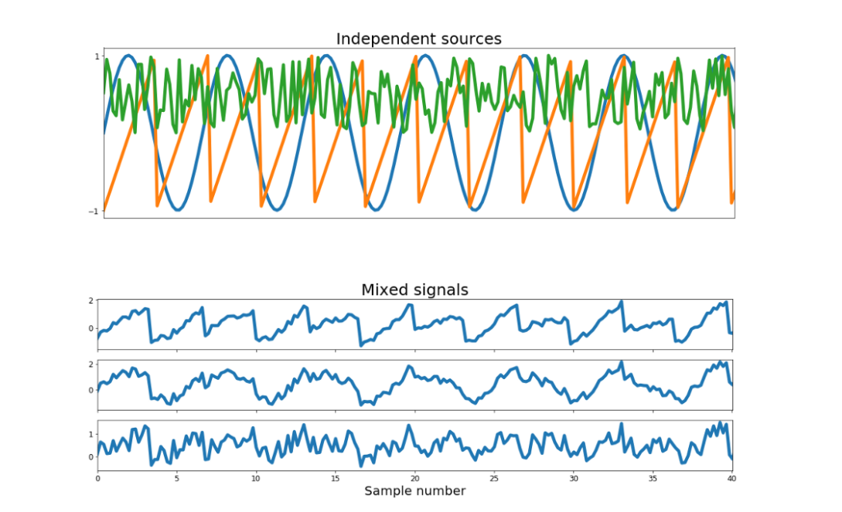

*Reference: towardsdatascience.com*

In this figure we can see the independent signals represented in the first plot graph are found as a part of mixed signal in the second plot graph where one signal can be seen similar to the sine wave and one signal dominating others.

After applying ICA, the resultant component graph plot looks like the following figures:

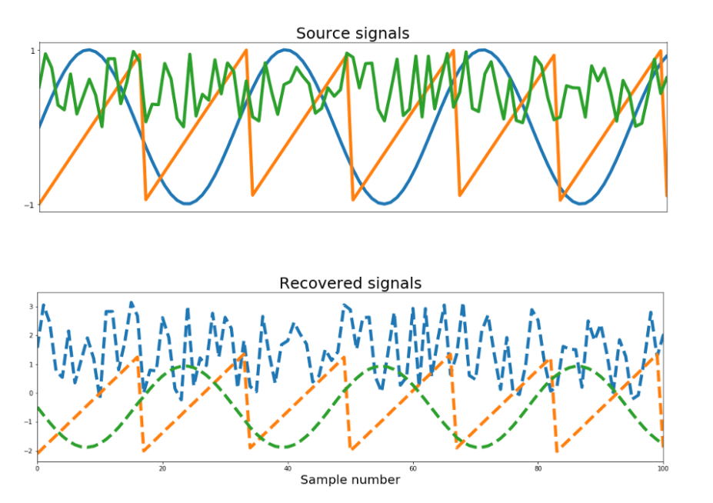

*Reference: towardsdatascience.com*